TURN OFF YOUR POP-UP BLOCKER AND ALLOW DOWNLOADED CONTENT FROM THE SITE BEFORE BEFORE ATTEMPTING TO OPEN THE PRINTABLE WALLET CARD AND LICENSE CERTIFICATE.
NOTE: Only one attempt is provided to access the printable wallet card and license certificate. The Board suggests saving the document before printing.
If the document does not open due to a pop-up blocker, you must contact the Board to have the document reset. 1-800-304-0853 or information@hblb.alabama.gov
Please include license number with all communications.

For a Corporate License
- From the menu of the Individual Overview Page, select Manage Corporation:
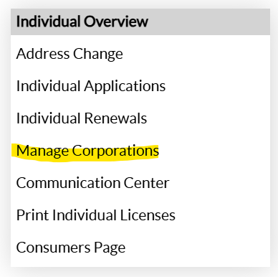
- From the grid that opens, select the Manage Corporation to the left of the license you wish to print
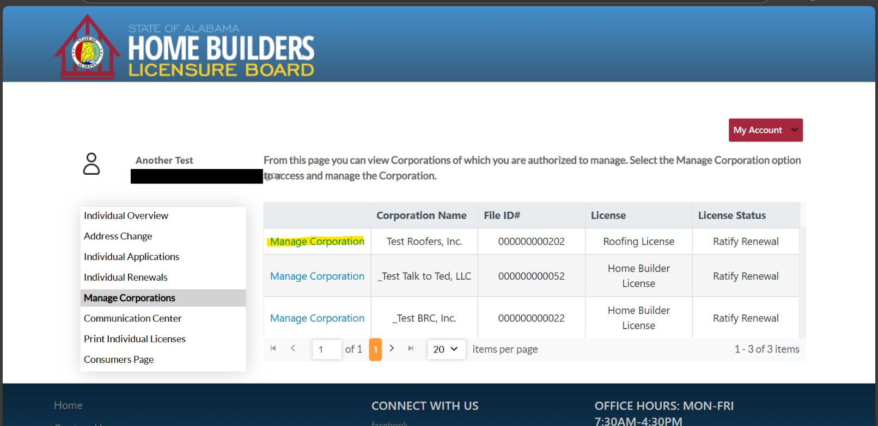
- From the menu of the Corporate Overview Page, select Print Corporation Licenses
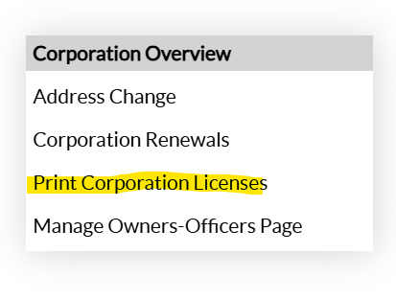
- From the grid that displays, select Open to the left of the license you wish to print
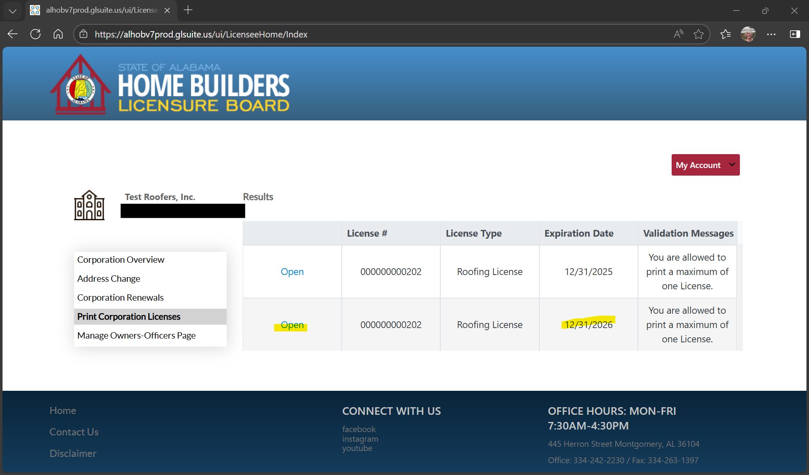
- A PDF document will open that may be saved to your computer and printed.

